Experiment

**Premise**

* Subjects will lay in the fMRI scanner and drink either appetitive or neutral juice. They will be cued before juice consumption about the probability of receiving the appetitive juice. Sometimes the outcome will be ignored and the subject will receive no juice.

**Player**

* Just lays there and drinks.

**Environment**

* A PsychoPy experiment in the scanner. A tube will run from juice press to subject’s mouth.

**Experiment**

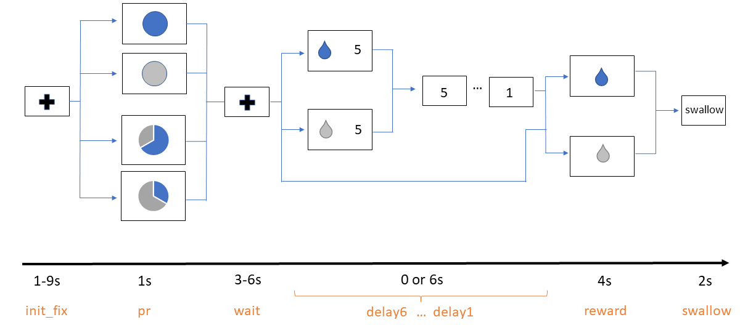

Pre-Experiment

* Appetitive juice is selected prior to experiment by liking rating task (0 to 5). Neutral juice is a saline solution made of the ionic components of saliva.
* Instructional period with 10 practice trials on laptop, no juice.

Screen 1: init_fix

* Subjects fixate on a fixation cross for 1-9 s, uniformly drawn.

Screen 2: pr

* A pie chart is presented with the probability of appetitive (blue) vs neutral (grey) juice for 1 s.

Screen 3: wait

* A fixation cross is presented for 3-6 s, uniformly drawn.

Screen 4: delay

* This screen only appears in the delay condition.
* The screen will present a water drop stimulus (blue: appetitive; grey: neutral) on the left. A timer will appear on the right side of the screen, counting down from 6 s.

Screen 5 : reward

* The screen will present a water drop stimulus on the left side of the screen, like in the delay screen for 4 s.
* Juice is inserted into subject’s mouth in this trial. Subjects will be instructed prior to experiment to hold juice in their mouth until prompted to swallow.

Screen 6: swallow

* Subject prompted to swallow juice for 2 s.

**Trial Structure**

|  |  |  |  |
| --- | --- | --- | --- |
|  | | **Delay** | |
| **0** | **6** |
| **Probability** | **0** | 16 | 16 |
| **1/3** | 0 | 32 |
| **2/3** | 0 | 32 |
| **1** | 16 | 16 |

Total of 128 trials, split into 4 blocks of 32 trials. Conditions are randomly ordered and distributed across the 4 blocks, subject to the constraint that each block has 8 no delay trials and 24 delay trials. There are a total of 32 no delay trials and 96 delay trials.

No delay trials are 16.5 s on average. Delay trials are 22.5 s on average. Each block is

Each block is 11 m 12 s. Total task time is 44 m 48 s.

I estimate roughly 10 minutes for appetitive juice selection, 15 minutes of instruction period before the experiment, and 15 minutes of cumulative break time between blocks.

This totals 40 minutes of non-task time, for a total 1 h 24 m 48 s of scanner time per subject.

I can book the scanner room for one, 2 h session per subject. I plan to pay subjects a $60 show-up fee (2 h * $30 per hour).

**Recording** **data**

* Generate a file that keeps track of:
  + Subject ID
  + Session
  + Block
  + Trial
  + Trial onset (using a timer that starts at the beginning of the block)
  + Initial fixation cross duration
  + Pie chart duration
  + Probability in pie chart
  + Waiting fixation cross duration
  + Delay duration
  + Onset of each delay screen
  + Onset of reward screen
  + The reward type
  + Reward screen duration
  + Onset of swallow screen
  + Swallow screen duration
  + Whole brain BOLD activity (which I believe will record one long dataset for each block)

**Interfacing with other hardware**

* PsychoPy needs to interface with juice pumps and the fMRI scanner.
  + Scanner sends input “5” when it starts scanning. Use this to begin experiment. And implement lots of experimenter-controlled checks/stops.
  + Not sure how juice pumps work yet.